Multi-Region PostgreSQL Testing Dashboard
Implementation Guide for Live Streams
 | 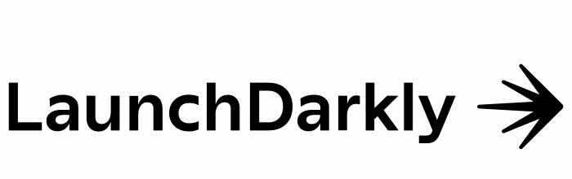
Author
Jay Miller
Stream Participants
Alexis Roberson
Jay Miller
Producer (TBA)
Streams 1 & 2 — Hosted on Jay Miller's YouTube Channel
Collaborator: Aiven · LaunchDarkly (optional)
Stream 3 — Hosted on Aiven's YouTube Channel
Collaborator: Jay Miller · LaunchDarkly (optional)

This document was generated using AI, prompted and directed by Jay Miller.

Part 1: Stream Overview & Goals
This guide outlines a three-stream live coding series that builds a web-based dashboard for testing PostgreSQL connectivity and performance across multiple geographic regions. The project demonstrates how modern cloud infrastructure (Aiven), feature management (LaunchDarkly), and lightweight web frameworks (FastAPI + HTMX) come together to solve real operational challenges.
System Architecture
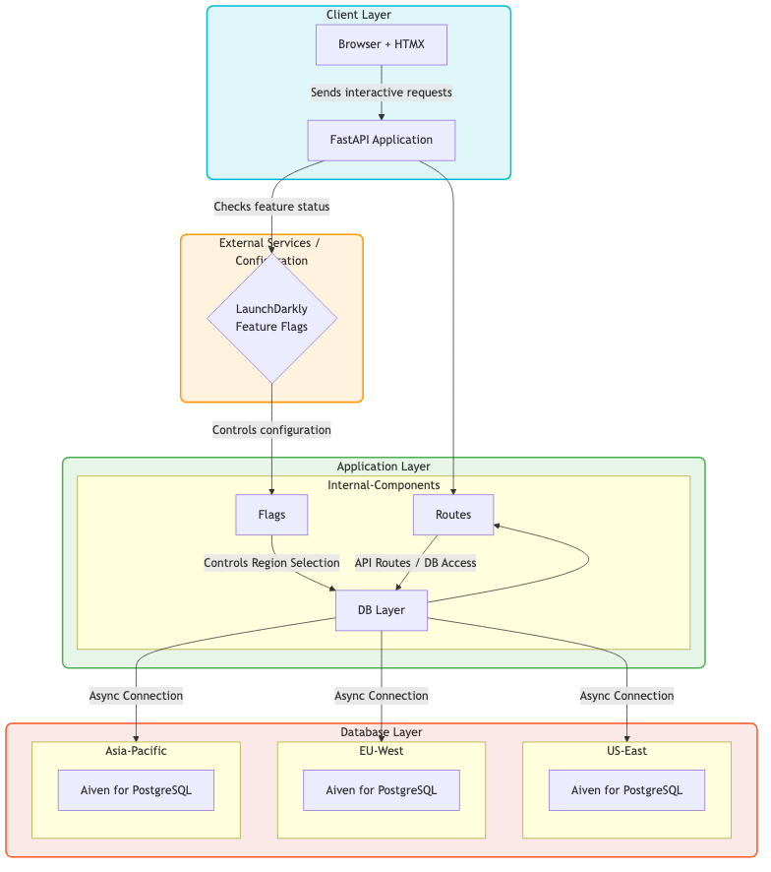
Figure 1: High-level architecture showing browser, application, and database layers
Region Selection & Routing
A key feature of the dashboard is the interactive region map. Users can see their latency to each database region and select routing preferences—automatically route to the lowest latency region, manually select a specific region, or force all traffic to the primary. The dashboard also displays the current request distribution across all regions.

Region | Role | Latency | Current Requests
US-East | PRIMARY | 25ms | 75%
EU-West | REPLICA | 120ms | 20%
Asia Pacific | REPLICA | 180ms | 5%
Region Routing: Auto Manual Primary Only

Current: US-East (lowest latency)
You have the option to perform a Manual Override of the selected region for routing requests.
Options
- Select a different region: You can change the selected region from the current setting (EU-West) to either US-East or Asia Pacific.

- By applying the override, all subsequent requests would be manually directed to the newly selected region (US-East or Asia Pacific), regardless of the automatic routing logic shown in the Figure 2 map.
- This action would likely alter the reported latency and the distribution of request display shown in the interactive map, as all traffic would now be forced to the override location.
What We're Building
The final product is an interactive dashboard that allows teams to quickly test and compare PostgreSQL performance across different regions. Users can check connection latency, measure performance under load, compare regions by distance, and identify the optimal region for their users—all from a single interface.
This type of tool is valuable for organizations running globally distributed applications who need visibility into their database layer without diving into command-line tools or separate monitoring systems.
Why These Technologies?
• Aiven for PostgreSQL — Provides managed PostgreSQL instances across multiple cloud regions with built-in connection pooling (PgBouncer), automated backups, and easy read replica setup. This removes the operational burden of managing PostgreSQL infrastructure.
• LaunchDarkly — Enables runtime control over which regions are available, which features are enabled, and who can access what. This allows instant region toggles during incidents and gradual rollout of new dashboard features.
• FastAPI — A modern Python framework with native async support, which is essential when testing multiple database regions simultaneously without blocking.
• HTMX — Delivers interactive UI updates by returning HTML fragments from the server, avoiding the complexity of a JavaScript framework while maintaining a responsive experience.

Stream Progression

Stream | Topics
Stream 1: Foundation | Project Setup, Aiven + HTMX
Stream 2: Advanced | Load Testing, Performance
Stream 3: Retrospective | Discoveries, Lesson

Stream 1: Foundation
Duration: 2 hours
Part 1 Goals (Hour 1):
• Set up the project structure and install dependencies
• Create PostgreSQL services in Aiven across 2-3 geographic regions
• Enable PgBouncer for connection pooling
• Build the database connection layer
• Write PostgreSQL queries that return meaningful connection metadata (server IP, version, process ID)
• Create the first API endpoint that tests connectivity to a single region
Part 2 Goals (Hour 2):
• Build the HTML templates with HTMX for interactive updates
• Create region cards that display connection results without page refresh • Integrate LaunchDarkly to control which regions are visible to users
• Set up feature flags for region availability
• Add the ability to test all regions simultaneously with async concurrency • Demonstrate LaunchDarkly targeting rules (enable regions by user location)
End State: A working dashboard that connects to multiple Aiven PostgreSQL regions, displays latency and connection details, and uses LaunchDarkly to control region visibility.
Stream 2: Diagnostics & Advanced Features
Duration: 2 hours
Part 1 Goals (Hour 1):
• Add database-level health metrics (cache hit ratio, active connections) • Enable and query pg_stat_statements for slow query analysis
• Build a comprehensive health check endpoint that returns multiple metrics • Create templates that display health data with visual indicators for warnings
Part 2 Goals (Hour 2):
• Implement latency testing based on simulated user distance from each region • Build load testing capabilities to measure performance under concurrent requests • Implement auto-refresh using HTMX polling controlled by LaunchDarkly numeric flags • Build a comparison view that ranks regions by latency and performance • Add error handling and connection timeouts
• Polish the UI with loading states and status indicators
End State: A full-featured dashboard with health metrics, load testing, distance-based latency comparisons, auto-refresh capabilities, and production-ready error handling.

Stream 3: Retrospective & Lessons Learned
Duration: ~1 hour
Hosted by: Aiven YouTube Channel
Stream 3 serves as a retrospective on the development process, highlighting discoveries, challenges, and insights gained during Streams 1 and 2.
Topics to Cover:
• Key technical decisions and why they were made (PgBouncer, async, HTMX) • Unexpected challenges encountered during development
• Performance discoveries when testing across regions
• How LaunchDarkly feature flags changed the development workflow
• What worked well and what we'd do differently
• Audience Q&A; and discussion
Goal: Provide viewers with practical insights they can apply to their own multi-region database projects, beyond just the code.
What Viewers Will Learn
• PostgreSQL Internals — How to query system catalogs (pg_stat_database, pg_stat_activity, pg_stat_statements) to understand what's happening inside the database.
• Aiven Platform — How to provision multi-region PostgreSQL and enable PgBouncer through the Aiven console.
• Feature Flags in Practice — Using LaunchDarkly beyond simple on/off toggles—controlling infrastructure visibility, gradual feature rollout, and runtime configuration.
• Async Python — Why async matters when querying multiple databases simultaneously, and how asyncpg enables non-blocking PostgreSQL access.
• HTMX Patterns — Building interactive dashboards that update in place without writing JavaScript, using server-rendered HTML fragments.
• Performance Testing — Measuring latency based on user distance from database regions and understanding how load affects response times.

Part 2: Technical Implementation
This section provides implementation guidance with focused code samples. The goal is to illustrate how components connect rather than provide copy-paste code blocks.
Project Structure
The application follows a standard FastAPI layout with routers for API endpoints, a templates directory for Jinja2/HTMX templates, and separate modules for database access, configuration, and feature flags.
app/
■■■ main.py # FastAPI application and lifespan
■■■ config.py # Region definitions and settings
■■■ database.py # Async connection helper
■■■ feature_flags.py # LaunchDarkly integration
■■■ queries.py # PostgreSQL query definitions
■■■ routers/
■ ■■■ pages.py # HTML page routes
■ ■■■ api.py # HTMX API endpoints
■■■ templates/
■■■ base.html
■■■ partials/ # HTMX response fragments
Configuration & Region Registry
Each Aiven region is defined with a name and reference to its connection string environment variable. Connection strings come from the Aiven console with PgBouncer enabled.
REGIONS = {
"us-east": {"name": "US East (Virginia)", "env_key": "AIVEN_PG_US_EAST"}, "eu-west": {"name": "EU West (Ireland)", "env_key": "AIVEN_PG_EU_WEST"}, }
Database Connection Layer
Since Aiven's PgBouncer handles connection pooling server-side, the client code is minimal. We use asyncpg for non-blocking connections and a simple context manager pattern.
@asynccontextmanager
async def get_connection(dsn: str):
conn = await asyncpg.connect(dsn=dsn, ssl="require")
try:
yield conn
finally:
await conn.close()
The ssl="require" parameter is essential—Aiven PostgreSQL requires encrypted connections.
HTMX Request Flow

HTMX Request Lifecycle
- Click Button
- HTMX POST Request Sent
- Check LaunchDarkly (Feature Flag Evaluation)
- Query PostgreSQL
- Return HTML Fragment
- DOM Updated (No page reload!)
PostgreSQL System Queries
Rather than a simple SELECT 1, we query PostgreSQL's system functions to return meaningful data about the connection.
Connection Information:
SELECT inet_server_addr()::text AS server_ip,
pg_backend_pid() AS backend_pid,
version() AS pg_version
This confirms which server you're connected to—essential when testing multi-region setups.
Load & Distance-Based Performance Testing
A key feature of the dashboard is measuring how latency varies based on the end user's distance from each database region, and how performance changes under load.
Distance-Based Latency:
The dashboard can test from multiple vantage points to show how geography affects response times. Users closer to US-East will see lower latency to that region, while users in Europe will see better performance from EU-West.
async def measure_latency(region_id: str, iterations: int = 5) -> dict: timings = []
for _ in range(iterations):
start = time.perf_counter()
async with get_connection(get_dsn(region_id)) as conn:
await conn.fetchval("SELECT 1")
timings.append((time.perf_counter() - start) * 1000)
return {"min": min(timings), "max": max(timings), "avg": sum(timings) / len(timings
)}

Concurrent Multi-Region Testing
Parallel Execution using asyncio.gather()

Results are ranked by latency:
- US-East: 45ms
- EU-West: 120ms
- Asia: 180ms
Load Testing:
To understand how regions perform under pressure, the dashboard can simulate concurrent connections and measure response degradation.
async def load_test(region_id: str, concurrent: int = 10) -> dict: async def single_query():
start = time.perf_counter()
async with get_connection(get_dsn(region_id)) as conn:
await conn.fetchval("SELECT 1")
return (time.perf_counter() - start) * 1000
tasks = [single_query() for _ in range(concurrent)]
timings = await asyncio.gather(*tasks)
return {"concurrent": concurrent, "avg_ms": sum(timings) / len(timings)}

HTMX Integration
HTMX attributes on HTML elements trigger server requests and update the page with returned HTML fragments. No JavaScript is required for basic interactivity.
Region Test Button:
<button hx-post="/api/regions/us-east/test"
hx-target="#result-us-east"
hx-indicator="#spinner-us-east">
Test Connection
</button>
hx-post triggers a POST request, hx-target specifies where to insert the response, and hx-indicator shows a loading element during the request.

Auto-Refresh Pattern:
<div hx-get="/api/regions/summary"
hx-trigger="every 30s"
hx-swap="innerHTML">
</div>
The polling interval can be controlled by a LaunchDarkly numeric flag, allowing runtime adjustment without redeployment.
LaunchDarkly Integration
LaunchDarkly provides runtime control over regions and features. The SDK evaluates flags based on user context, enabling targeting rules.
Region Availability Check:
def is_region_enabled(region_id: str, user_key: str) -> bool:
context = Context.builder(user_key).build()
return ld_client.variation(f"region-{region_id}-enabled", context, True) Suggested Flags:
Flag Key | Type | Purpose
region-{id}-enabled | Boolean | Enable/disable specific regions
enable-health-checks | Boolean | Show health check features
enable-load-testing | Boolean | Enable load testing feature
dashboard-refresh-seconds | Number | Auto-refresh polling interval

API Endpoint Pattern
Each API endpoint checks feature flags, queries the database, and returns an HTML partial that HTMX inserts into the page.
@router.post("/regions/{region_id}/test")
async def test_region(region_id: str, request: Request):
if not is_region_enabled(region_id, get_user_key(request)):
return HTMLResponse('<div class="error">Region unavailable</div>')
start = time.perf_counter()
async with get_connection(get_dsn(region_id)) as conn:
info = await conn.fetchrow(CONNECTION_INFO)
latency_ms = (time.perf_counter() - start) * 1000
return templates.TemplateResponse("partials/result.html", {...})

Aiven Setup Notes
The following steps happen in the Aiven console and are demonstrated live in the streams:
• Create PostgreSQL Services: One service per region, selecting the cloud provider and specific region for each.
• Enable PgBouncer: Under Connection pooling, enable PgBouncer in transaction mode. This provides a separate connection string on port 6543.
• Copy Connection Strings: Use the PgBouncer connection string (not direct) for the application. Store these as environment variables.
• Review Service Metrics: Use Aiven's built-in metrics to monitor connection counts, CPU usage, and disk I/O alongside our custom dashboard.
Performance Testing Reference
Test Type | What It Measures | Why It Matters
Single Latency | Round-trip time for one query | Baseline performance per region
Multi-Iteration | Min/max/avg across N queries | Latency consistency
Concurrent Load | Response under parallel requests | Scalability and pooling effectiveness
Cross-Region | All regions simultaneously | Comparison and routing decisions

Dependencies
fastapi
uvicorn[standard]
asyncpg
jinja2
python-dotenv
launchdarkly-server-sdk

